

**Capstone Project Report**

**Report 1 – Project Introduction**

– Hanoi, Jan 2025 –

**Table of Contents**

I. Record of Changes 3

II. Definition and Acronyms 4

III. Project Introduction 4

1. Overview 4

1.1 Project Information 4

1.2 Project Purpose 4

1.3 Project Stakeholders 4

2. Product Background 4

3. Existing Solutions 5

3.1 System Name1 5

3.2 System Name2 5

4. Solution & Opportunity 5

5. Project Scope & Limitations 5

5.1 Major Features 5

5.2 Limitations & Exclusions 6

# I. Record of Changes

|  |  |  |  |
| --- | --- | --- | --- |
| Date | A* M, D | In charge | Change Description |
|  |  |  |  |
|  |  |  |  |
|  |  |  |  |
|  |  |  |  |
|  |  |  |  |
|  |  |  |  |
|  |  |  |  |
|  |  |  |  |
|  |  |  |  |
|  |  |  |  |
|  |  |  |  |
|  |  |  |  |
|  |  |  |  |

*A - Added M - Modified D - Deleted

# II. Definition and Acronyms

*[Fill all the definitions, acronyms,… used within the whole project in the table format as below]*

|  |  |
| --- | --- |
| **Acronym** | **Definition** |
| COS | Cafeteria Ordering System |
| … |  |

# III. Project Introduction

## 1. Overview

### 1.1 Project Information

* English name: ***Cafeteria Ordering System***
* Vietnamese name: ***Hệ thống đặt hàng quán cà phê***
* Project code: ***COS***
* Group name: ***SEP490-G4***
* Software type: ***Mobile App***

### 1.2 Project Purpose

*[Provide some sentence to describe general project purpose like sample below]*

<<Sample: The purpose of this project is to develop CraigsBay Auction House (CAH) system. The CraigsBay Auction House is designed to be an online auction and trading site with built-in real-time communication tools between potential bidders and the auction owner. The document is intended to serve as the guideline and intended goals for the implementation of the various functions of the program.>>

### 1.3 Project Stakeholders

|  |  |  |  |
| --- | --- | --- | --- |
| **Full Name** | **Role** | **Email** | **Mobile** |
| Nguyen Trung Kien | Lecturer | abc@fe.edu.vn | 0912345678 |
| Nghiem Thi Thuy Van | Leader | xyz@fpt.edu.vn |  |
| Dam Thi Huyen | Member | abx@fpt.edu.vn |  |
| Dao Thi Phuong | Member | .. |  |

## 2. Product Background

• Nếu phát triển sản phẩm thương mại để phân phối rộng rãi trên thị trường, cần mô tả rõ bối cảnh thị trường hiện tại, cũng như nhu cầu và mong muốn của nhóm khách hàng tiềm năng mà sản phẩm đang nhắm đến.

• Nếu sản phẩm được tạo ra để giải quyết một vấn đề cụ thể hoặc làm theo yêu cầu của khách hàng, cần mô tả chi tiết cách thức khách hàng đang vận hành, những vấn đề họ đang gặp phải mà sản phẩm sẽ giải quyết, hoặc nhu cầu cụ thể mà khách hàng cần được đáp ứng.

*[This section summarizes the rationale for the new product. Provide a general description of the history or situation that leads to the recognition that this product should be built. You should also mention here the information on the customer /the people who raise project idea/request]*

<<Sample: Employees at the company Process Impact presently spend an average of 65 minutes per day going to the cafeteria to select, purchase, and eat lunch. About 20 minutes of this time is spent walking to and from the cafeteria, selecting their meals, and paying by cash or credit card. When employees go out for lunch, they spend an average of 90 minutes off-site. Some employees phone the cafeteria in advance to order a meal to be ready for them to pick up. Employees don’t always get the selections they want because the cafeteria runs out of certain items. The cafeteria wastes a significant quantity of food that is not purchased and must be thrown away. These same issues apply to breakfast and supper, although far fewer employees use the cafeteria for those meals than for lunch.>>

## 3. Existing Solutions

*[List out and describe systems which might help solving the problems you listed above or the systems in which you can learn/refer the features for your system design]*

Mô tả các phần mềm hiện có trên thị trường là đối thủ cạch tranh với sản phẩm đồ án định làm.Hoặc mô tả các phần mềm mà đang giải quyết được nhu cầu của khách hàng. Ưu điểm nhược điểm của những phần mềm này, đối chiếu với nhu cầu của khách hàng. Mỗi mục 3.1, 3.2, 3.x là một phần mềm hiện có.

### 3.1 System Name1

*[Write the brief descriptions of the system, the link, the system actors, features, pros, cons, etc.]*

### 3.2 System Name2

…

## 4. Solution & Opportunity

*[Describe the market/business opportunity that exists or the business problem that is being solved. Describe the market in which a commercial product will be competing or the environment in which an information system will be used. This may include a brief comparative evaluation of existing products and potential solutions, indicating why the proposed product is attractive. Identify the problems that cannot currently be solved without the product, and how the product fits in with market trends or corporate strategic directions]*

Mô tả cụ thể hơn về nhu cầu của các lớp người dùng, khách hàng cần một sản phẩm như thế nào? Để giải quyết được nhu cầu mô tả ở mục 2 của tài liệu này. Tưởng tượng là sau khi sản phẩm làm xong thì người dùng sẽ sử dụng sản phẩm này như thế nào? Cách thức mà sản phẩm này đáp ứng được nhu cầu của khách hàng/người dùng

<<Sample: Many employees have requested a system that would permit a cafeteria user to order meals (defined as a set of one or more food items selected from the cafeteria menu) on line, to be picked up at the cafeteria or delivered to a company location at a specified time and date. Such a system would save employees time, and it would increase the chance of their getting the items they prefer. Knowing what food items customers want in advance would reduce wastage in the cafeteria and would improve the efficiency of cafeteria staff. The future ability for employees to order meals for delivery from local restaurants would make a wide range of choices available to employees and provide the possibility of cost savings through volume discount agreements with the restaurants.>>

## 5. Project Scope & Limitations

*[The project scope defines the concept and range of the proposed solution. It’s also important to define what will not be included in the product. Clarifying the scope and limitations helps to establish realistic expectations of the many stakeholders. It also provides a reference frame against which proposed features and requirements changes can be evaluated. Proposed requirements that are out of scope for the envisioned product must be rejected, unless they are so beneficial that the scope should be enlarged to accommodate them (with accompanying changes in budget, schedule, and/or resources)]*

### 5.1 Major Features

*[Include feature tree or a numbered list of the major features of the new product, emphasizing those features that distinguish it from previous or competing products/systems. Specific user requirements and functional requirements may be traced back to these features.]*

Sử dụng sơ đồ mindmap hoặc feature tree để mô tả các tính năng chính của chương trình. Và mô tả ngắn các tính năng này bằng lời văn, đánh mã định danh duy nhất cho mỗi tính năng

<<Sample:

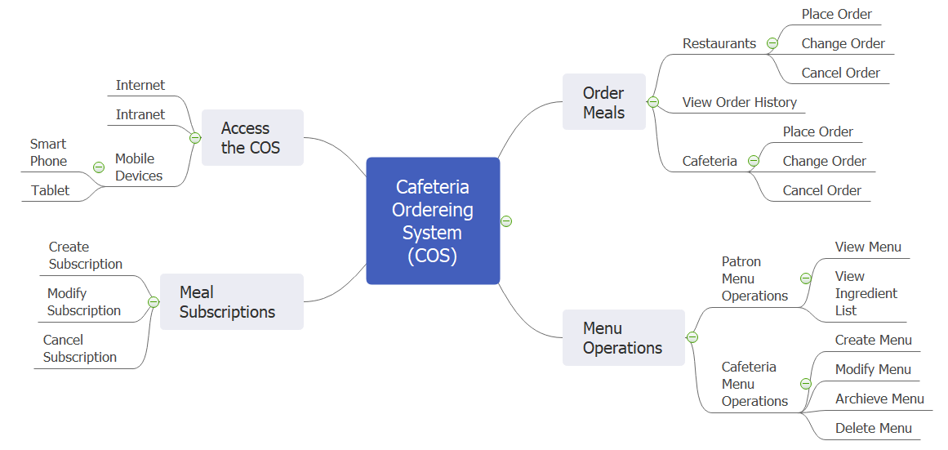

FE-01: Order and pay for meals from the cafeteria menu to be picked up or delivered.

FE-02: Order and pay for meals from local restaurants to be delivered.

FE-03: Create, view, modify, and cancel meal subscriptions for standing or recurring meal orders, or for daily special meals.

FE-04: Create, view, modify, delete, and archive cafeteria menus.

FE-05: View ingredient lists and nutritional information for cafeteria menu items.

>>

### 5.2 Limitations & Exclusions

*[Identify any product features or characteristics that a stakeholder might anticipate, but which are not planned to be included in the new product.]*

Limitation là những tính năng cần thiết của sản phẩm nhưng ở giai đoạn này chưa làm được do các ràng buộc về phạm vi, thời gian, nguồn lực…Nhưng trong tương lai sẽ làm.

Exclusions là những chức năng nằm ngoài phạm vi của chương trình, hiện tại không làm và tương lai cũng không làm nó

<<Sample:

LI-1: Some food items that are available from the cafeteria will not be suitable for delivery, so the menus available to patrons of the COS must be a subset of the full cafeteria menus.

LI-2: The COS shall be used only for the cafeteria at the Process Impact campus in Clackamas, Oregon.

>>

<<Another sample:

For the functionality of the auction and trade, the application will be limited to being only the mediator between users in terms of communication and will not participate in the actual exchange of the goods. The application will not be implemented to prevent nor will it take responsibility for any fraudulent acts by any users. Photo sharing services will be provided by using the web service Flickr©. SMS services will be handled by Zeep Mobile©. Our application will provide chatting services for users in order to facilitate their trading activities

>>